**Step 1 :** **Perform below steps**

1. **Goto Jenkins dashboard and click configure for webapp project**
2. **Under build step change clean packages ,click on save**

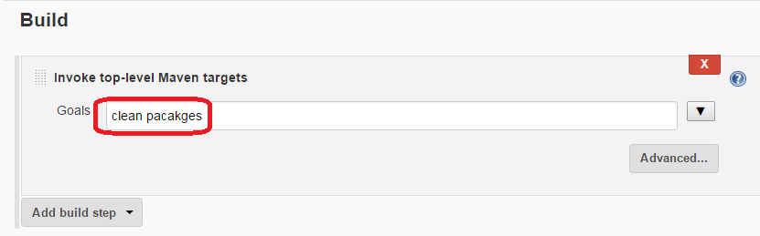

1. **Click on build now**

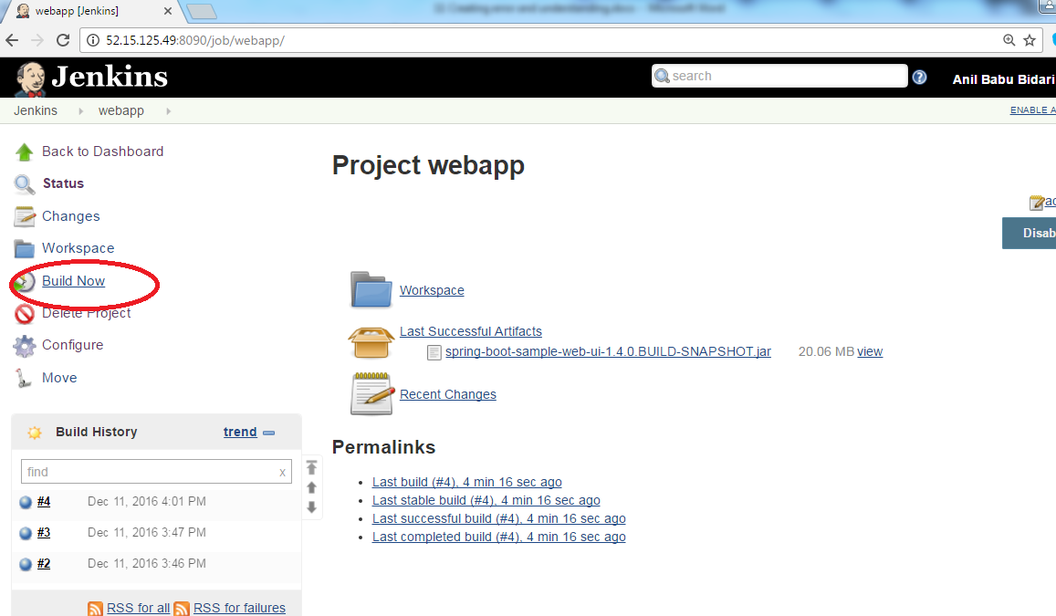

1. **On dashboard u should build state failure**

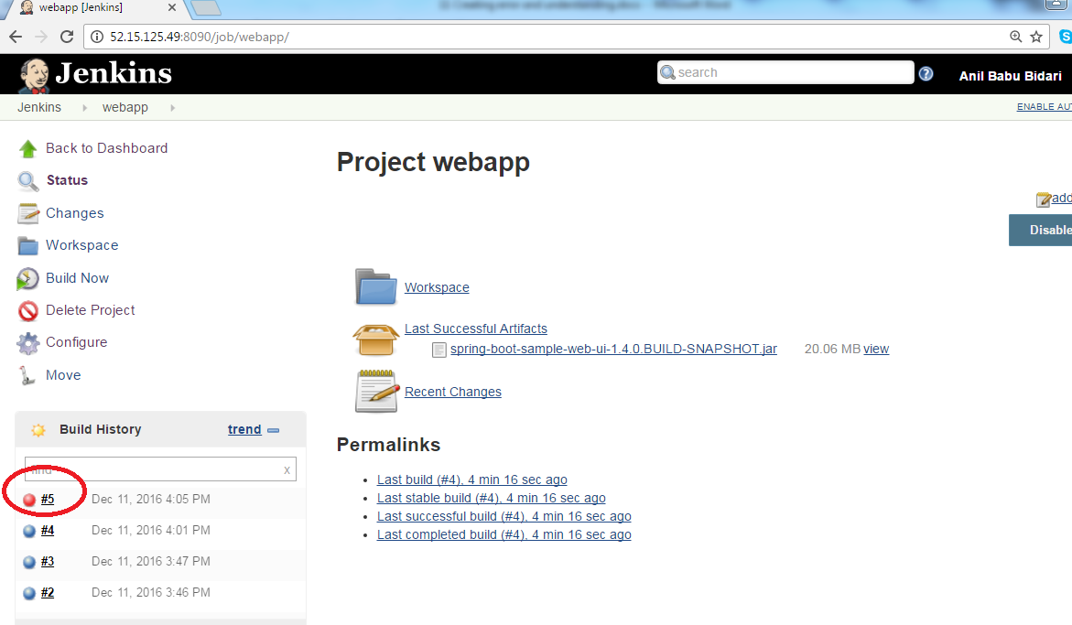

1. **Goto console output and it should show u what problem he has**

